Assignment No. 01  
University Academic Management System

**Question No. 01**

Draw a Context Level Data Flow Diagram (DFD) for the above scenario

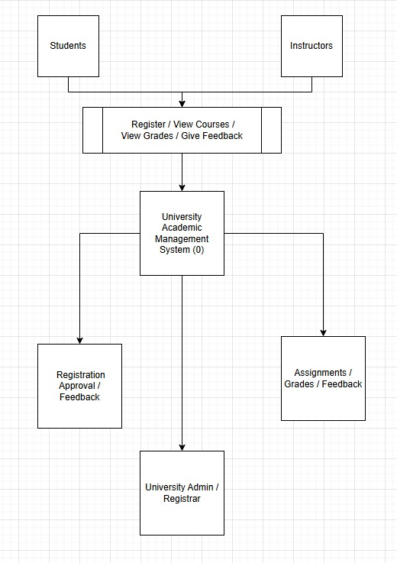

________________________________________________________

**Question No. 02**

Draw a complete Entity Relationship Diagram (ERD) of the system, specifying the cardinality (one-to-many, many-to-many, etc.).



